How to start a Scheduler

Go to start and enter sched and new task schdeular is open

<http://windows.microsoft.com/en-in/windows/schedule-task#1TC=windows-7>

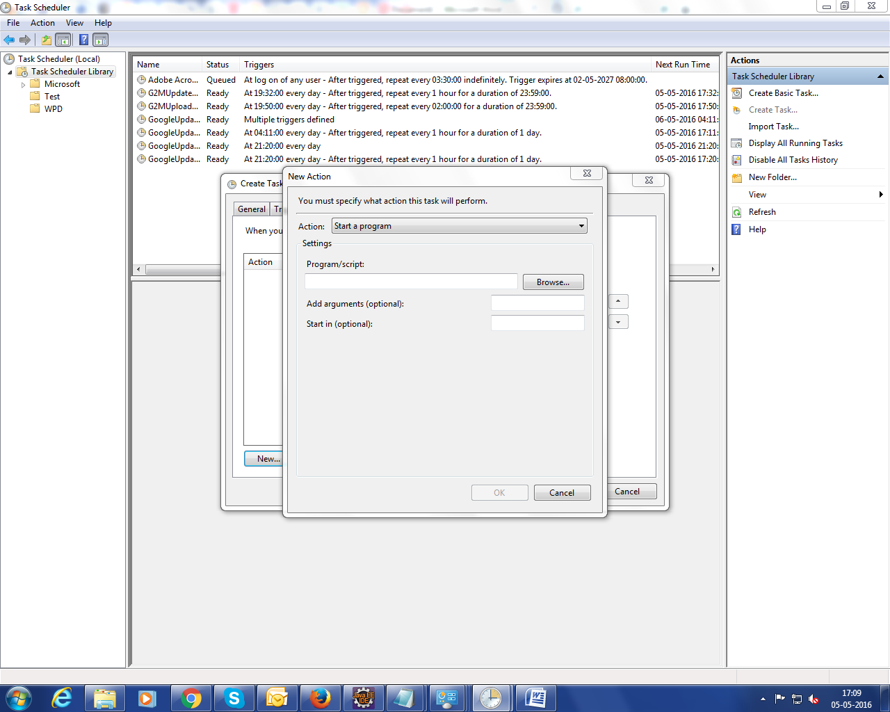

Java exe scheduler

\\10.78.7.60\Selenium_Scripts\Webdriver2.0\SeleniumHubandNodes\Quitjavaexe.bat

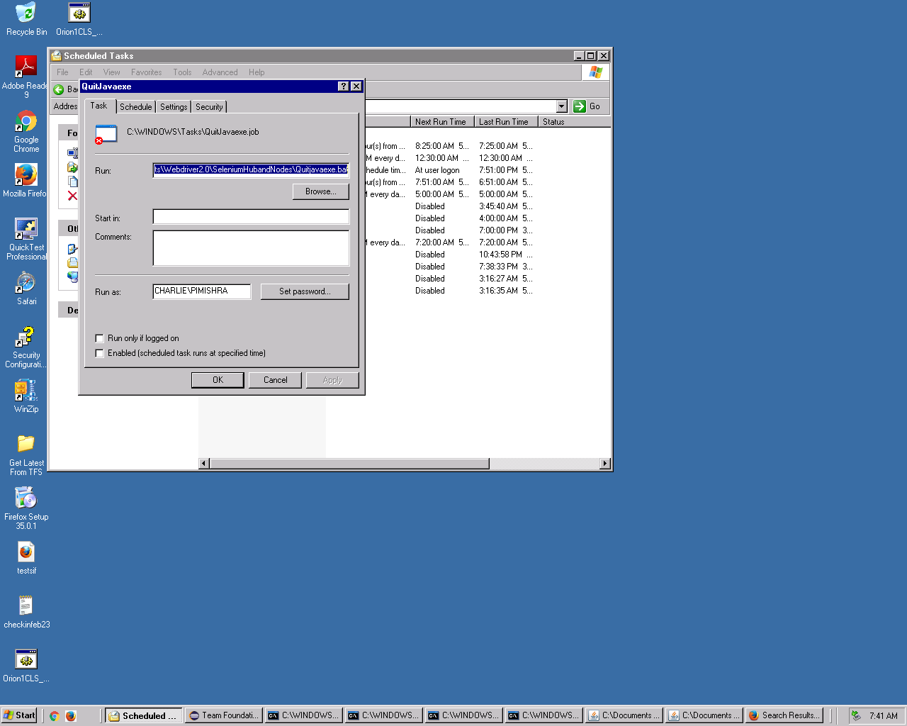

Run value "C:\Documents and Settings\pimishra.CHARLIE\Desktop\SRMBUILD.bat"

Start in value "C:\Documents and Settings\pimishra.CHARLIE\Desktop"

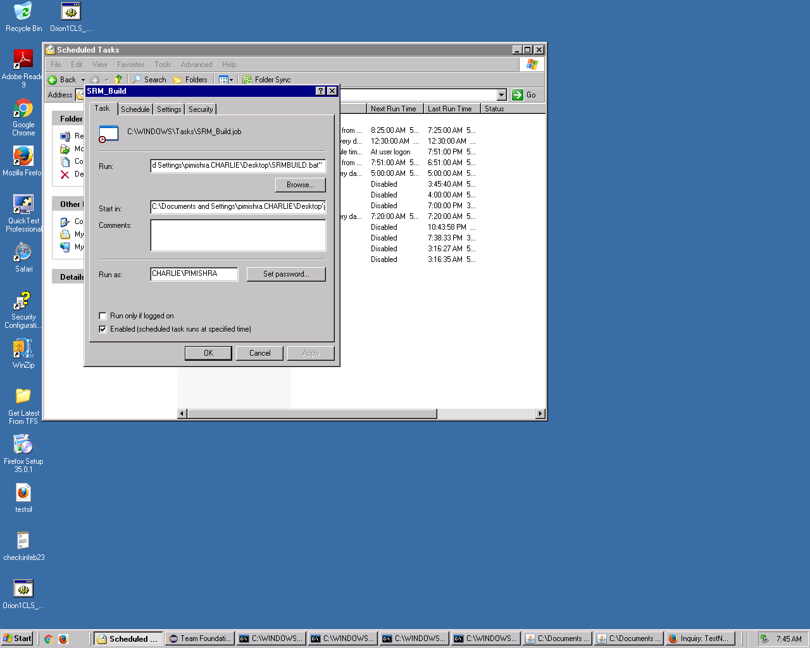R

S

Start hub run \\10.78.7.60\Selenium_Scripts\Webdriver2.0\SeleniumHubandNodes\StartHub.bat

\\10.78.7.60\Selenium_Scripts\Webdriver2.0\SeleniumHubandNodes

\\10.78.7.60\Selenium_Scripts\Webdriver2.0\SeleniumHubandNodes\StartNode_FireFox_5558.bat

\\10.78.7.60\Selenium_Scripts\Webdriver2.0\SeleniumHubandNodes

